Skill-3
ORDERS TABLE
STEP 1: CREATE TABLE

CREATE TABLE orders (
ord_no INT PRIMARY KEY,
purch_amt DECIMAL(10,2),
ord_date DATE,
customer_id INT,
salesman_id INT
);

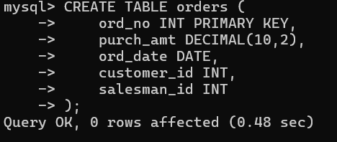

STEP 2: INSERT DATA

INSERT INTO orders VALUES
(70001,150.50,'2012-10-05',3005,5002),
(70009,270.65,'2012-09-10',3001,5005),
(70002,65.26,'2012-10-05',3002,5001),
(70004,110.50,'2012-08-17',3009,5003),
(70007,948.50,'2012-09-10',3005,5002),
(70005,2400.60,'2012-07-27',3007,5001),
(70008,5760.00,'2012-09-10',3002,5001),
(70010,1983.43,'2012-10-10',3004,5006),
(70003,2480.40,'2012-10-10',3009,5003),
(70012,250.45,'2012-06-27',3008,5002),
(70011,75.29,'2012-08-17',3003,5007),
(70013,3045.60,'2012-04-25',3002,5001);

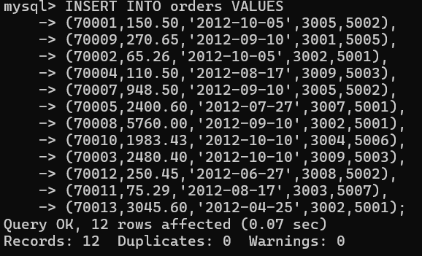

QUESTION 1 - WHERE CLAUSE

SCENARIO:
Finance wants all orders whose purchase amount is greater
than $2,000.

QUERY:

SELECT *
FROM orders
WHERE purch_amt > 2000;

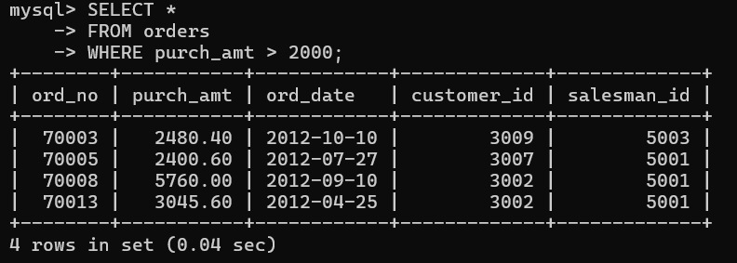

QUESTION 2 - WHERE CLAUSE

SCENARIO:
Management wants all orders placed on 2012-09-10.

QUERY:

SELECT *
FROM orders
WHERE ord_date='2012-09-10';

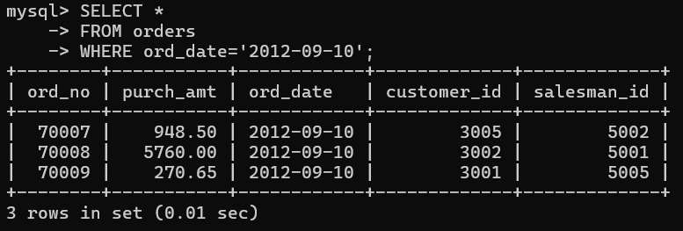

QUESTION 3 - WHERE CLAUSE

SCENARIO:
Find all orders handled by salesman 5001.

QUERY:

SELECT *
FROM orders
WHERE salesman_id=5001;

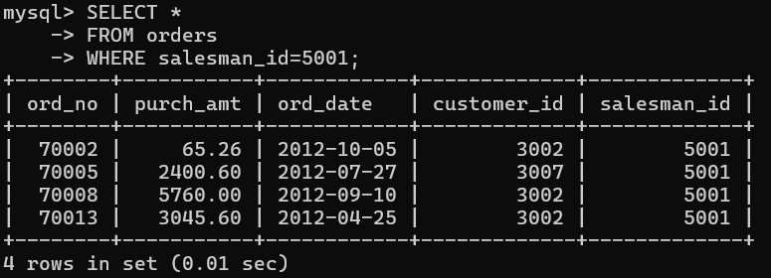

QUESTION 4 - ORDER BY

SCENARIO:
CEO wants to see orders ranked from highest amount to
lowest amount.

QUERY:

SELECT *
FROM orders
ORDER BY purch_amt DESC;

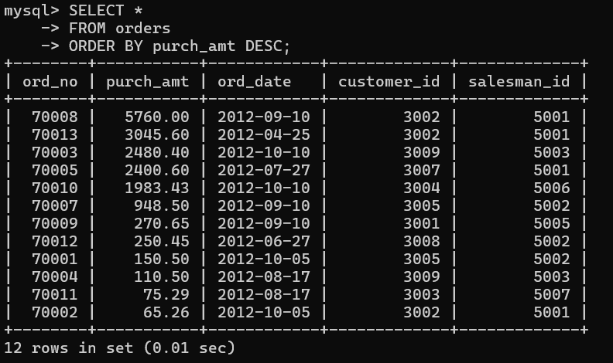

QUESTION 5 - ORDER BY

SCENARIO:
Operations team wants oldest orders first.

QUERY:

SELECT *
FROM orders
ORDER BY ord_date;

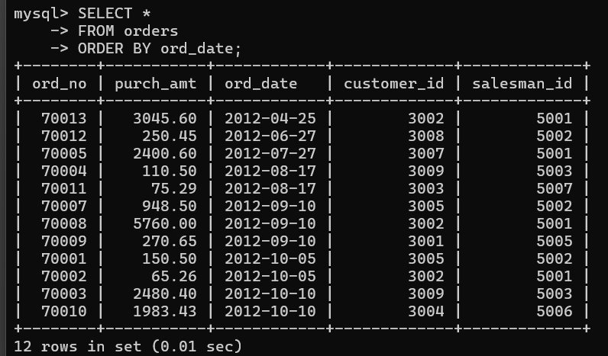

QUESTION 6 - SUM()

SCENARIO:
Finance department wants total revenue generated.

QUERY:

SELECT SUM(purch_amt) AS total_revenue
FROM orders;

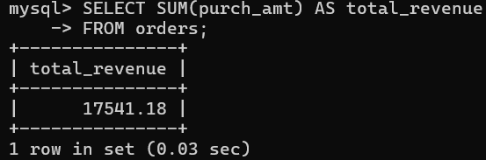

QUESTION 7 - AVG()

SCENARIO:
Management wants average order value.

QUERY:

SELECT AVG(purch_amt) AS average_order
FROM orders;

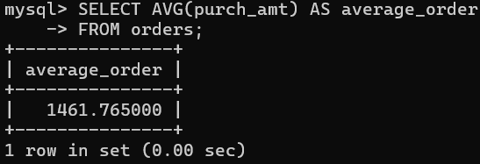

QUESTION 8 - MAX()

SCENARIO:
Find the highest order amount.

QUERY:

SELECT MAX(purch_amt) AS highest_order
FROM orders;

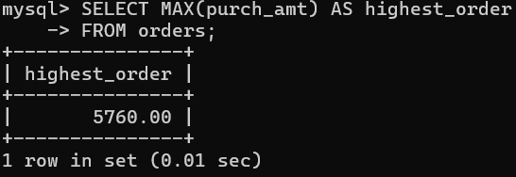

QUESTION 9 - MIN()

SCENARIO:
Find the lowest order amount.

QUERY:

SELECT MIN(purch_amt) AS lowest_order
FROM orders;

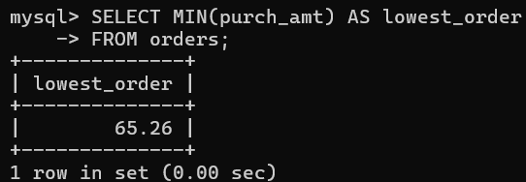

QUESTION 10 - COUNT()

SCENARIO:
Find total number of orders.

QUERY:

SELECT COUNT(*) AS total_orders
FROM orders;

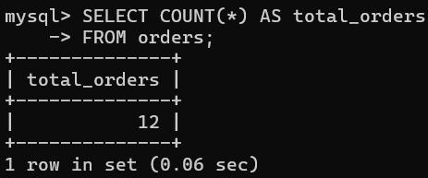

QUESTION 11 - GROUP BY

SCENARIO:
Sales director wants total sales generated by each
salesman.

QUERY:

SELECT salesman_id,
SUM(purch_amt) AS total_sales
FROM orders
GROUP BY salesman_id;

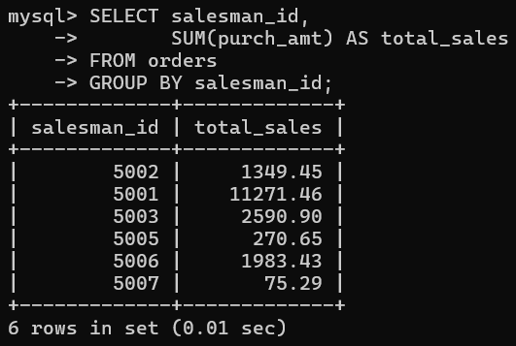

QUESTION 12 - GROUP BY

SCENARIO:
Marketing wants total purchases made by each customer.

QUERY:

SELECT customer_id,
SUM(purch_amt) AS total_purchase
FROM orders
GROUP BY customer_id;

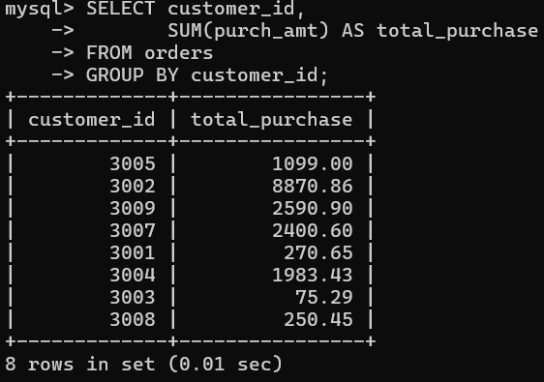

QUESTION 13 - GROUP BY + MAX()

SCENARIO:
Find the highest order placed by each customer.

QUERY:

SELECT customer_id,
MAX(purch_amt) AS highest_purchase
FROM orders
GROUP BY customer_id;

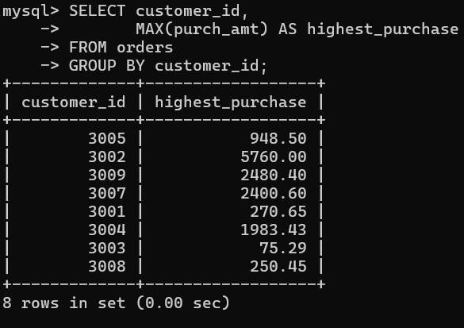

QUESTION 14 - GROUP BY + HAVING

SCENARIO:
Company rewards salesmen whose total sales exceed $3,000.

QUERY:

SELECT salesman_id,
SUM(purch_amt) AS total_sales
FROM orders
GROUP BY salesman_id
HAVING SUM(purch_amt) > 3000;

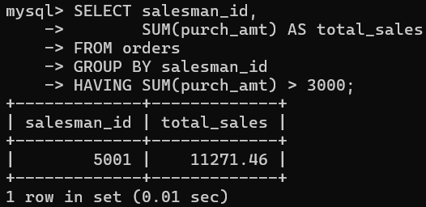

QUESTION 15 - GROUP BY + HAVING

SCENARIO:
Find customers whose total purchases exceed $2,500.

QUERY:

SELECT customer_id,
SUM(purch_amt) AS total_purchase
FROM orders
GROUP BY customer_id
HAVING SUM(purch_amt) > 2500;

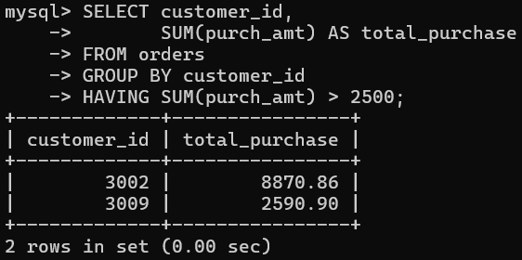

QUESTION 16 - GROUP BY + HAVING

SCENARIO:
Find customers who placed more than one order.

QUERY:

SELECT customer_id,
COUNT(*) AS total_orders
FROM orders
GROUP BY customer_id
HAVING COUNT(*) > 1;

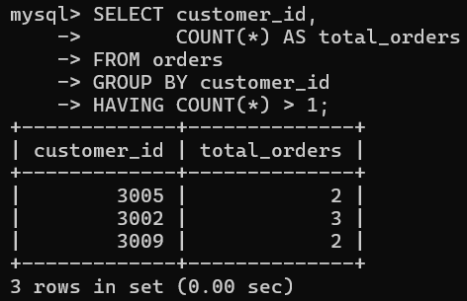

QUESTION 17 - GROUP BY + HAVING + ORDER BY

SCENARIO:
Management wants top customers ranked by spending.

QUERY:

SELECT customer_id,
SUM(purch_amt) AS total_purchase
FROM orders
GROUP BY customer_id
HAVING SUM(purch_amt) > 1000
ORDER BY total_purchase DESC;

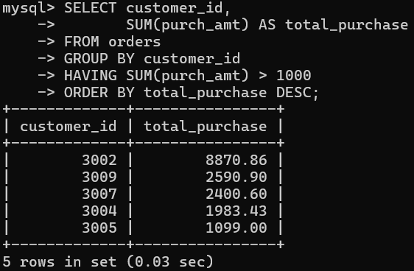

QUESTION 18 - BETWEEN + HAVING

SCENARIO:
Find customers whose maximum purchase is between
$2,000 and $6,000.

QUERY:

SELECT customer_id,
MAX(purch_amt) AS max_purchase
FROM orders
GROUP BY customer_id
HAVING MAX(purch_amt) BETWEEN 2000 AND 6000;

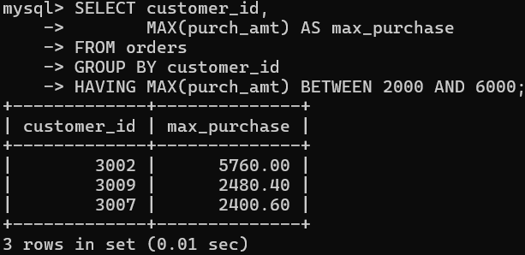

QUESTION 19 - COUNT + HAVING

SCENARIO:
Find salesmen who handled at least two orders.

QUERY:

SELECT salesman_id,
COUNT(*) AS total_orders
FROM orders
GROUP BY salesman_id
HAVING COUNT(*) >= 2;

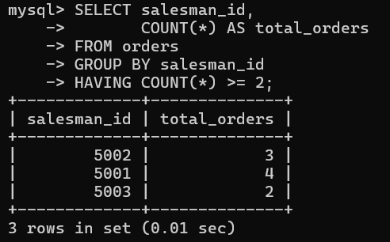

QUESTION 20 - MAX + GROUP BY + HAVING

SCENARIO:
Management wants daily highest purchases above $2,000.

QUERY:

SELECT ord_date,
MAX(purch_amt) AS highest_purchase
FROM orders
GROUP BY ord_date
HAVING MAX(purch_amt) > 2000;

